Dylan Johnson

CSC 230 Database Design

Professor Ivan Gappy

**Holidays: A Database for Automations**

Automations have become essential to a lot of business practices. Even though programs may not be fully autonomous, there are still plenty of programs that will create, process, and even deploy data. These tools have allowed employees and developers alike to have more time to spend on more business-oriented work, rather than busy work that it is very easy for a computer to process. The next step in these processes would be to take human interaction completely out of the picture. There are plenty of tasks that require human interaction to get started and even tell the program what to do as it works through itself. Looking past some particulars of specific programs, there are programs that need to be ran every business day. The challenge there is, not every Monday to Friday is a business day (and depending on the business need, the weekends as well). There have been plenty of attempts to work around this specific need, however one that could be very helpful is to have a database that stores information on days that could and would affect business practices.

**Industry Overview:**

A database of this caliber could be implemented at any number of companies. If created as an open-source project any business could adapt it to their specific needs. Without getting too deep into the possibilities of a fully functioning product, the idea would be to store and make accessible to any and all programs so that the automations will only run when they are needed or when information is available. This would allow to make fully autonomous solutions for any number of business needs and practices.

**Issue/Opportunity:**

A lot of current programs need to be kicked off by an employee, or have a trigger that will make the program run. This requires a lot of human interaction. Even with all the experience in the world, humans are still prone to errors, some better at this than others. By having this database, any task could be automated from start to finish, taking away the need for human interaction with the exception of quality control. A lot of programs are run after the initial process has been kicked off. The idea here is to have pre set times any day that will start a process. If the day is not a work day and does not need to be run, this database will tell the program that, and will cancel the process. If the program requires information from previous days, this database will tell the program that the direct previous day is not the day to work with. A computer is only as smart as it is programmed, therefore it needs to have all the information possible to complete a task correctly and efficiently, the first time.

**Database Solution:**

This would be a very simple database, that would require some upkeep as the days in question are not the same year over year. While the design of this database is not advanced by any means, the possibilities it will allow for is endless. The information this database will store could start out with relatively small amount of information that would grow as more opportunities arise for ease of use to the developer that is attaching their specific program to it. With the idea that this would be an ever-growing database, there are some basic principles that would need to be included to be useful out of the box. Firstly, this database is essentially a calendar storing information on what holidays are on a specific day. Once every Holiday is outlined for each day, it can then be labeled as what kind of Holiday it is. Since not every Holiday has an effect on business practices, there would be a column labeling it that day with keywords that to identify if this program is causing a disruption to business flow or not. At its most basic components, that is all it would need with current use case in mind.

**Database Normalization Process:**

When working through the normalization process there was multiple instances of the initial database design that did not pass the test. As a result, there has been a complete rework of the design, one that would yield the same result, but in a more functional/realistic way. The database was broken up into more functional tables that can provide more accurate output providing more efficient results. The initial design was essentially one big table with each column built of the previous. That does not pass second normal form. To fix this each aspect that was not dependent on the primary key was broken off into its own table. This allows for a user to query the database and joint data as needed. Instead of the database being the desired output, the database provides otherwise useless data which can be made useful through a query.

**Conclusion:**

The original intention of this database is to ease the production of automations. Instead of having to hard code any use case into an automation that would have to be changed every year. This database would store all of that information in a central location. Then, any program would be able to call this database to know if it should be running, or if it can take a day off.

Table 1 ERD:

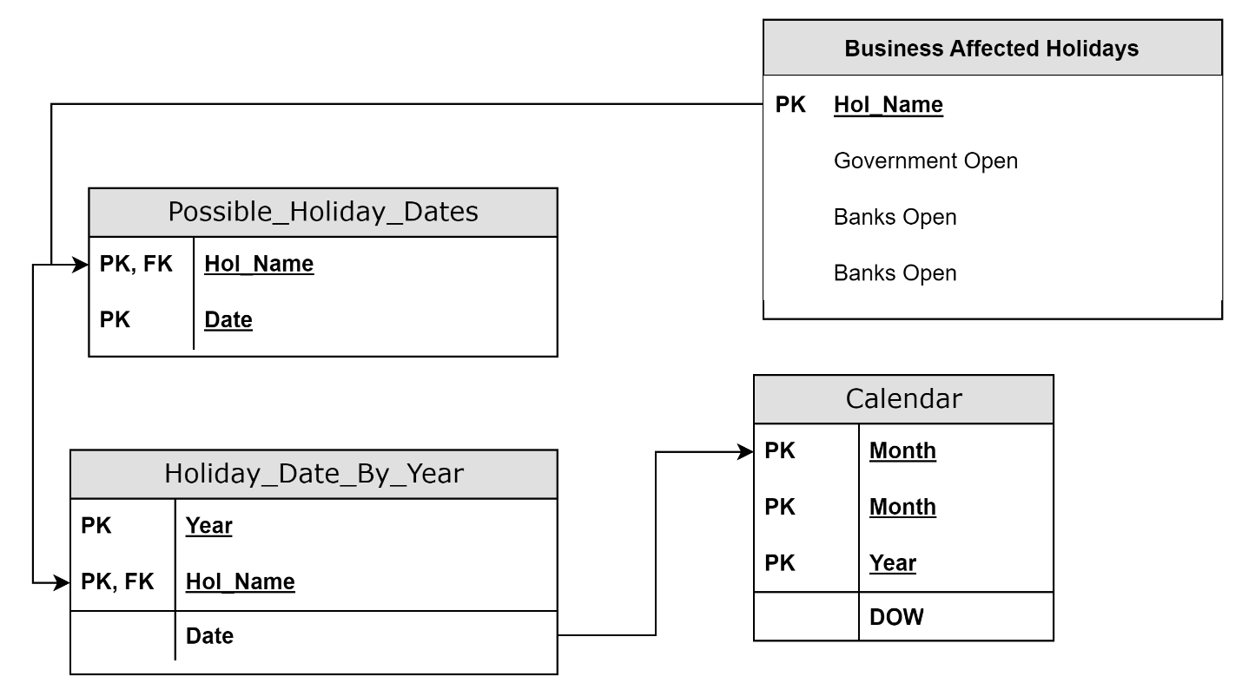

Table 2 Data Dictionary:

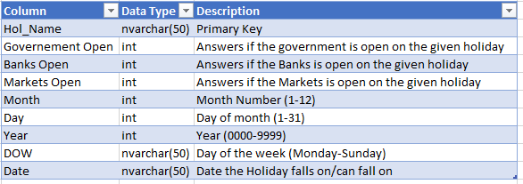

Table 3 Updated Database Tables:

